

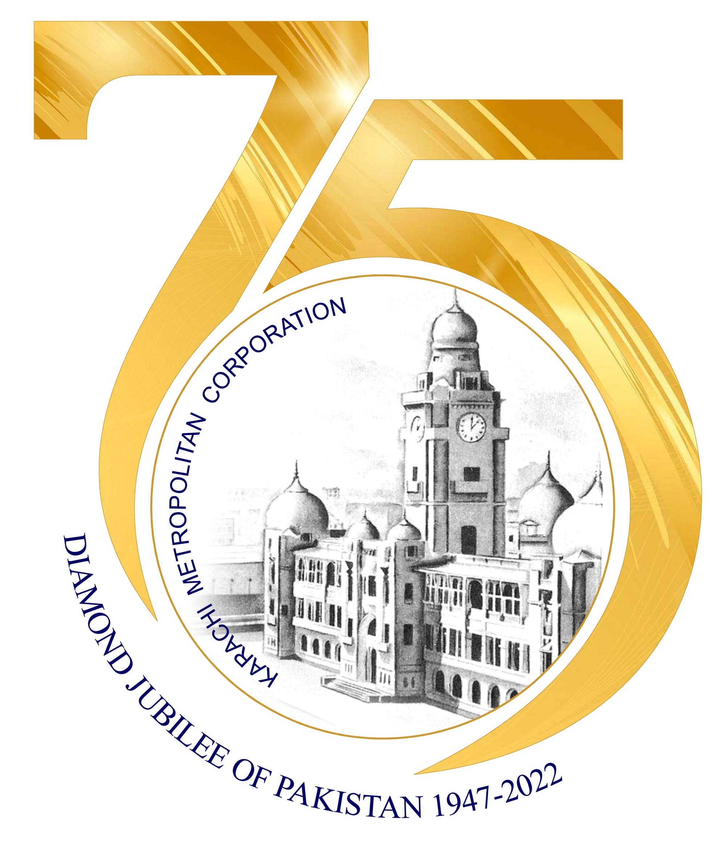

PRESS RELEASE
Phone: 99215134 - 99216335
Ref.No. KMC/INF/098/2024 Date: 31/03/2024
E-Mail: kmc.information.dptt@gmail.com
KARACHI METROPOLITAN CORPORATION

Karachi Mar 31: Mayor Karachi Barrister Murtaza Wahab has said that nursing is a sacred profession, along with employment, service to suffering humanity is also included in it. Nursing holds much importance all over the world. 130 students will get free nursing training and quality education in the Nursing Institute. All efforts will be made for ensuring as better functioning of Karachi Institute of Heart Disease. Public-private partnership is very important for running institutions, all medical and other institutions can be enabled under public-private partnership, citizens of Karachi have the right to get treatment facilities.

He expressed these views while addressing the ceremony organized after the inauguration of Karachi Institute of Health Sciences (Nursing) along with Deputy Mayor Karachi Salman Abdullah Murad on Sunday. Pakistan People's Party Deputy parliamentary leader in the city council Dil Mohammad, Juman Darwan, Mayor Karachi Spokesperson for Political Affairs Karamullah Waqasi and local leaders, doctors, paramedical staff and other officers were also present on this occasion.

Mayor Karachi Barrister Murtaza Wahab said that the building in which he is present is the property of the KMC, unfortunately it has not been paid attention to in the past. Unfortunately, decision-making was stopped, this building was like this for twelve and thirteen years, someone thought that what could be the benefit of this building to the city, as the mayor of Karachi, I thought to activate this building for the citizens of Karachi. 130 children will get free education in this institute.

We have faced difficulties and political criticism in doing this work, if there is good intention in the decision, then Allah Almighty helps, he said that large number of people are required in the field of nursing in different countries of the world including Europe, America, Canada and Europe, this building was built for a long time in the Karachi Institute of Heart Diseases, but nursing education was not being given.
KMC is trying to improve the condition of 14 major hospitals, he said that the nursing school in Abbasi Shaheed Hospital has been closed for a long time, efforts will be made to activate Abbasi Shaheed Hospital Nursing School and nursing school in Orangi Town as well. By renovating emergency ward, gynecological ward and children's ward in Abbasi Shaheed Hospital, we have provided the best facilities to the public.

In response to a question from the media, Mayor Karachi Barrister Murtaza Wahab said that there is a demand for the nursing sector all over the world at the moment, Insha Allah , the nurses trained here will also serve in international hospitals. The sector is highly valued, Spencer Eye Hospital and Nursing School will also be built in Orangi Town, we want to give skills to the children of Karachi, we will establish more institutions under Public Private Partnership to provide skills to the youth.

He said that the coming year will prove to be better for this province and for the city. In nine months, we have not given any job in the KMC , the abuse of this city has to be taken into account, he said that I have doubled the income of kmc, one and a half billion rupees will be recovered soon, which will be invested in the improvement of the city.

Mayor Karachi said that the conditions of this city have been worsened by spreading negative propaganda, Jamaat-e-Islami, PTI and MQM had criticized the making of the hospital. Crack down by Pakistan People's Party mayor in the Water Board has benefited the city , will continue operations against illegal hydrants and water thieves.

End….

KMC News and photos are also sent via e-mail. Please check your inbox

